**EXPERIMENT – 5**

**AIM: -** Experiments on Packet capture tool: Wireshark

**CAPTURING AND ANALYSING PACKETS USING WIRESHARK TOOL:**

**Packet 1:**

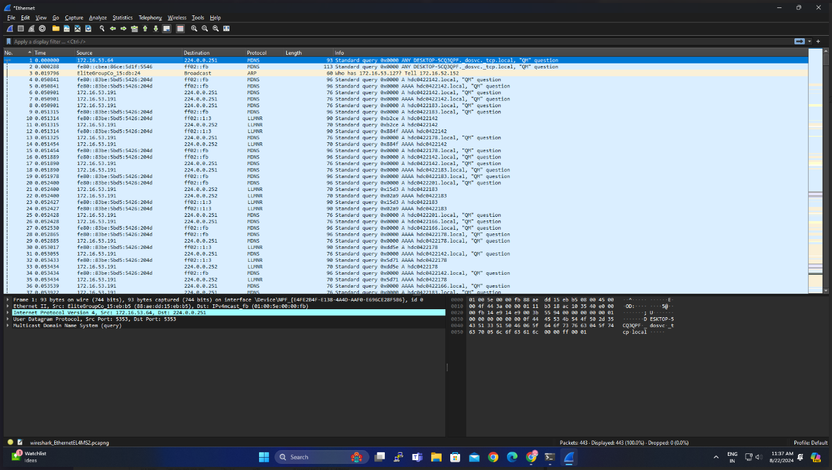

**Packet 2:**

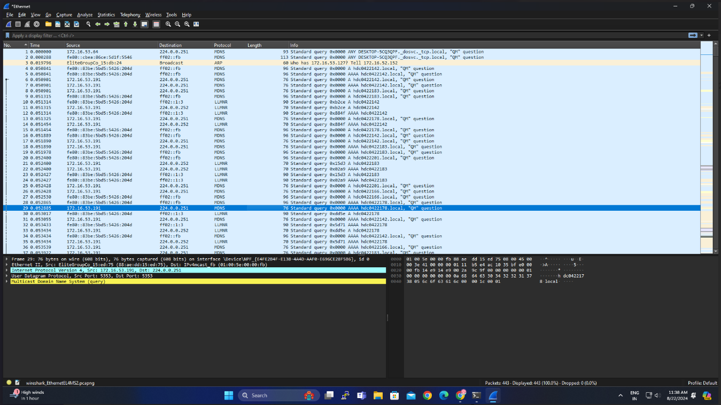

**Packet 3:**

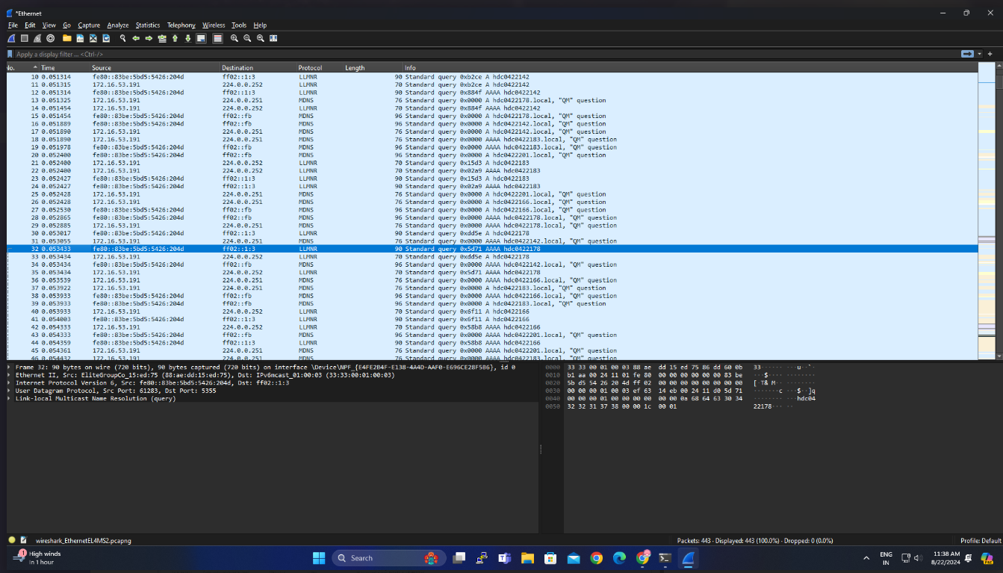

**Packet 4:**

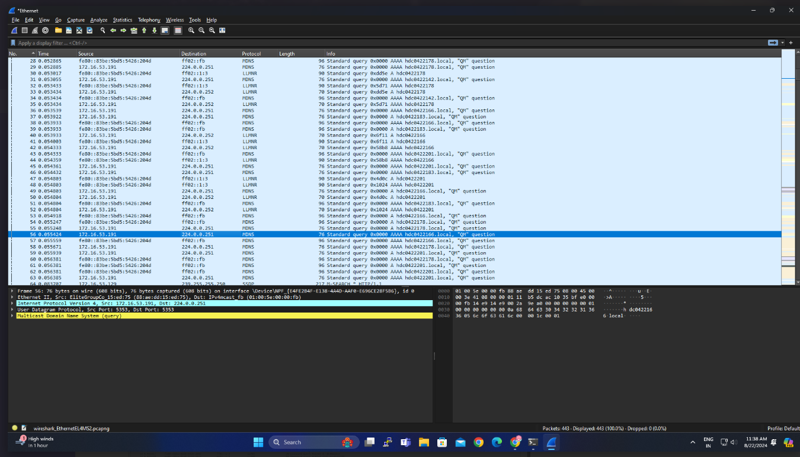

**Packet 5:**

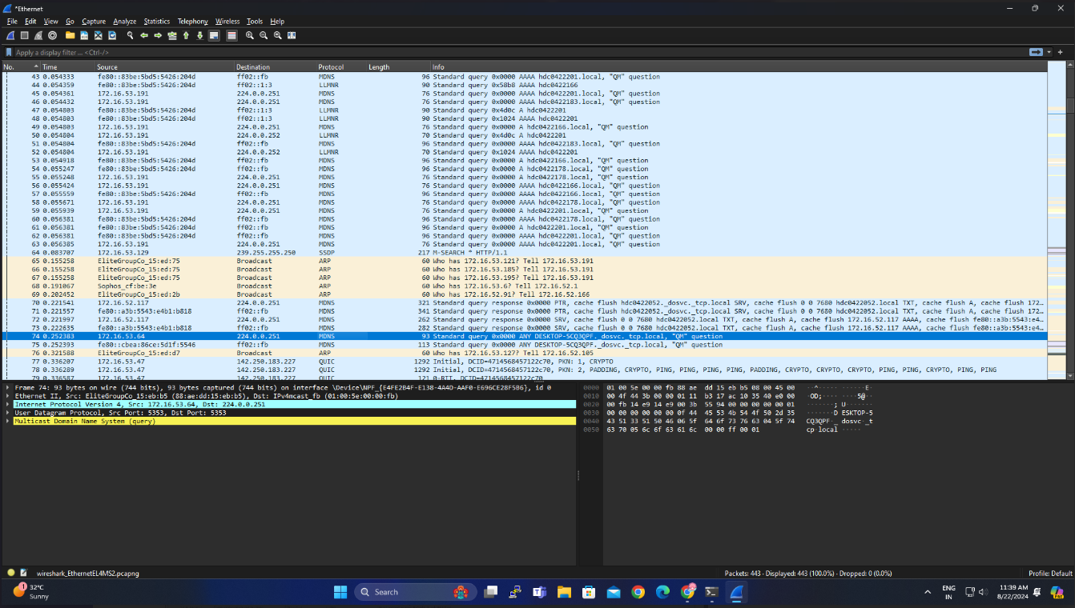

**RESULT: -**

Capturing and analysing the packets have been done successfully using Wireshark.